**BUSINESS DATA**

**ANALYSIS REPORT**

Table of Contents

Problem1 5

1.1 What is the probability that a randomly chosen player would suffer an injury? 5

1.2 What is the probability that a player is a forward or a winger? 6

1.3 What is the probability that a randomly chosen player plays in a striker position and has a foot injury? 6

1.4 What is the probability that a randomly chosen injured player is a striker? 6

1.5 What is the probability that a randomly chosen injured player is either a forward or an attacking midfielder? 7

Problem2 7

2.1 What are the probabilities of a fire, a mechanical failure, and a human error respectively? 8

2.2 What is the probability of a radiation leak? 8

2.3 Suppose there has been a radiation leak in the reactor for which the definite cause is not known. What is the probability that it has been caused by: 9

A Fire. 9

A Mechanical Failure. 9

A Human Error. 9

Problem3 9

3.1 What proportion of the gunny bags have a breaking strength less than 3.17 kg per sq cm? 10

3.2 What proportion of the gunny bags have a breaking strength at least 3.6 kg per sq cm.? 11

3.3 What proportion of the gunny bags have a breaking strength between 5 and 5.5 kg per sq cm.? 12

3.4 What proportion of the gunny bags have a breaking strength NOT between 3 and 7.5 kg per sq cm.? 12

Problem4 13

4.1 What is the probability that a randomly chosen student gets a grade below 85 on this exam? 13

4.2 What is the probability that a randomly selected student scores between 65 and 87? 14

4.3 What should be the passing cut-off so that 75% of the students clear the exam? 14

15

Problem5 15

5.1 Earlier experience of Zingaro with this particular client is favourable as the stone surface was found to be of adequate hardness. However, Zingaro has reason to believe now that the unpolished stones may not be suitable for printing. Do you think Zingaro is justified in thinking so? 16

Let's write the null and alternate hypotheses: 17

5.2 Is the mean hardness of the polished and unpolished stones the same? 18

Let's write the null and alternate hypotheses: 18

Problem6 20

Problem7 24

7.1 Test whether there is any difference among the dentists on the implant hardness. State the null alternative hypotheses. Note that both types of alloys cannot be considered together. You must state the null and alternative hypotheses separately for the two types of alloys.? 26

7.2 Before the hypotheses may be tested, state the required assumptions. Are the assumptions fulfilled? Comment separately on both alloy types.? 28

7.3Irrespective of your conclusion in 2, we will continue with the testing procedure. What do you conclude regarding whether implant hardness depends on dentists? Clearly state your conclusion. If the null hypothesis is rejected, is it possible to identify which pairs of dentists differ? 28

7.4Now test whether there is any difference among the methods on the hardness of dental implant, separately for the two types of alloys. What are your conclusions? If the null hypothesis is rejected, is it possible to identify which pairs of methods differ? 30

7.5Now test whether there is any difference among the temperature levels on the hardness of dental implant, separately for the two types of alloys. What are your conclusions? If the null hypothesis is rejected, is it possible to identify which levels of temperatures differ? 32

7.6Consider the interaction effect of dentist and method and comment on the interaction plot, separately for the two types of alloys? 34

7.7Now consider the effect of both factors, dentist, and method, separately on each alloy. What do you conclude? Is it possible to identify which dentists are different, which methods are different, and which interaction levels are different? 35

**List of Figures**

Figure 1:Venn Diagram of the probability of events 8

Figure 2: Normal Distribution of Strength of Gunny Bags 10

Figure 3 : propotion of gunny bags having a strength less than 3.17 kg per sq 11

Figure 4 proportion of gunny bags having a strength at least 3.6 kg per sq cm 11

Figure 5: proportion of gunny bags having a breaking strength between 5 and 5.5 kg per sq cm 12

Figure 6: proportion of gunny bags not having a breaking strength between 3 and 7.5 kg per sq cm 12

Figure 7 Normal Distribution of grades of the final examination in a training course 13

Figure 8: Density distribution of Scores with shaded area less than 85 13

Figure 9: Density distribution of Scores with shaded area between 65 and 87 14

Figure 10:Passing Cut off to clear the exam 15

Figure 11:Plotting of calculated T value 18

Figure 12: Plotting of calculated T value of samples of polished and unpolished means 20

Figure 13: Boxplot of No of Push-ups Before Program 21

Figure 14: Boxplot of No of Push-ups After Program 21

Figure 15: New column calculating the difference between number of push-ups before and after 22

Figure 16: Plotting the difference of means 22

Figure 17: Plotting of calculated T value of difference of samples of before and After the program 24

Figure 18:Top 5 records of Dental Implant Hardness Data 24

Figure 19: Columns of the Dataset 25

Figure 20: Plotting of Response Variable 25

Figure 21: Plotting the Implant Hardness among the dentists for both Alloys 27

Figure 22: One -way ANOVA test for Dentists for both Alloys 29

Figure 23: Plotting the Implant Hardness among the Methods for both Alloys 30

Figure 24: One -way ANOVA test for Methods for both Alloys 31

Figure 25: Tukey test for Methods for both Alloys 32

Figure 26: Plotting the Implant Hardness among the Tempertature for both Alloys 33

Figure 27: One -way ANOVA test for Tempertature for both Alloys 34

Figure 28: Plotting the Interaction effect of dentist and method 35

Figure 29 Plotting the mean Implant Hardness among the Dentists with different Methods for both Alloy1 36

Figure 30: Plotting the mean Implant Hardness among the Dentists with different Methods for both Alloy2 36

Figure 31: Two way ANOVA testing Dentist and Methods and Interaction of Both the independent variables 38

Figure 32:Tukey Test for interaction for Alloy 1 39

Figure 33: Tukey Test for interaction for Alloy 2 40

**List of Tables**

**Table 1: Displaying Top 5 records from the dataset** 15

**Table 2 :Numerical summarization of the dataset** 16

**Table 3:Skewness of Variables** 16

**Table 4: Displaying top 5 records of the dataset of Aquarius health club before and after program** 20

**Table 5: Numerical summarization of the dataset before and after the program** 21

**Table 6: describing the sample difference** 22

**Table 7: Describing Response Variable** 25

**Table 8: Data set description after changing datatypes.** 26

**Table 9: Crosstab of Dentist vs other variables** 26

**List of equations**

Equation 1: One sample T test 17

Equation 2: 2 sample Independent T test 19

Equation 3: Paired T test 23

Equation 4: ANOVA one way test 29

Equation 5: Two ANOVA with Interaction 38

# Problem1

A physiotherapist with a male football team is interested in studying the relationship between foot injuries and the positions at which the players play from the data collected

|  |  |  |  |  |  |
| --- | --- | --- | --- | --- | --- |
|  | Striker | Forward | Attacking Midfielder | Winger | **Total** |
| Players Injured | 45 | 56 | 24 | 20 | 145 |
| Players Not Injured | 32 | 38 | 11 | 9 | 90 |
| Total | 77 | 94 | 35 | 29 | 235 |

**Ans:** Total Players=235

Total Number of Players Injured =145

Total Number of Players Not Injured =90

Total Number of Strikers =77

Total Number of Forward =94

Total Number of Attacking Midfielder =35

Total Number of Winger =29

Total Number of Strikers who are injured=45

Total Number of Strikers who are not injured=32

Total Number of Forwards who are injured=56

Total Number of Forwards who are not injured=38

Total Number of Attacking Midfielders who are injured=24

Total Number of Attacking Midfielders who are not injured=11

Total Number of Wingers who are injured=20

Total Number of Wingers who are not injured=9

## What is the probability that a randomly chosen player would suffer an injury?

**Ans:**Let P (Player Suffer Injury) be the probability that a randomly chosen player would suffer injury.

P (Player Suffer Injury) = Total Number of Players Injured /Total Players=145/235=0.617.

**Probability that a randomly chosen player would suffer an injury is 0.617**

## 1.2 What is the probability that a player is a forward or a winger?

**Ans:** Let P (Forward or Winger) be the probability that a randomly chosen player is either a forward or winger. Using Addition Rule of Probability P(A or B)=P(A)+P(B)−P(A∩B)

Probability of player being forward and winger is P(A∩B) . They are mutually exclusive events; hence P(A∩B) is 0

Total Number of Forward /Total Players + Total Number of Winger /Total Players

P(Forward or Winger)=94/235 +29/235 - 0 = 0.5234

**Probability that a randomly chosen player is a forward or a winger is 0.5234**

## 1.3 What is the probability that a randomly chosen player plays in a striker position and has a foot injury?

**Ans:** Let P (Foot injury and Striker) be the probability that a randomly chosen player plays in a striker position and has a foot injury

Its numbers of Total Number of Strikers who are injured /Total Players

P (Foot injury and Striker)) =45/235

**Probability that that a randomly chosen player plays in a striker position and has a foot injury is 0.1915**

## 1.4 What is the probability that a randomly chosen injured player is a striker?

**Ans:** Let P (Injured player being Striker) be the probability that a randomly chosen Injured player plays in a striker position

Its Total Number of Strikers who are injured / Total Number of Players Injured

P (Injured player being Striker)) =45/145

**Probability that that a randomly chosen Injured player plays in a striker position is 0.3103**

## 1.5 What is the probability that a randomly chosen injured player is either a forward or an attacking midfielder?

**Ans:** Let P (Injured Forward or Injured Attacking Midfielder) be the probability that a randomly chosen Injured player is either a Forward or Attacking Midfielder. Using Addition Rule of Probability P (A or B) =P(A)+P(B)−P(A∩B)

Probability of Injured player being forward and Attacking Midfielder is P(A∩B). They are mutually exclusive events; hence P(A∩B) is 0

Its Total Number of Forwards who are injured /Total Injured Players + Total Number of Attacking Midfielders who are injured /Total Injured Players

P (Injured Forward or Injured Attacking Midfielder) =56/145 + 24/145

**Probability that that a randomly chosen Injured player plays in a Forward or attacking Midfielder position is 0.5517**

# Problem2

An independent research organization is trying to estimate the probability that an accident at a nuclear power plant will result in radiation leakage. The types of accidents possible at the plant are, fire hazards, mechanical failure, or human error. The research organization also knows that two or more types of accidents cannot occur simultaneously.

According to the studies carried out by the organization, the probability of a radiation leak in case of a fire is 20%, the probability of a radiation leak in case of a mechanical 50%, and the probability of a radiation leak in case of a human error is 10%. The studies also showed the following;

* The probability of a radiation leak occurring simultaneously with a fire is 0.1%.
* The probability of a radiation leak occurring simultaneously with a mechanical failure is 0.15%.
* The probability of a radiation leak occurring simultaneously with a human error is 0.12%.

**Ans:**



Figure :Venn Diagram of the probability of events

**Given**

The probability of a radiation leak in case of a fire p(r|f) =0.2

The probability of a radiation leak in case of a mechanical failure p(r|m) =0.5

The probability of a radiation leak in case of a human error p(r|h) =0.1

The probability of a radiation leak and fire simultaneously p (r∩f) =0.001 as depicted in the black shaded area

The probability of a radiation leak and mechanical failure simultaneously p (r∩m) =0.0015 as depicted in the red shaded area

The probability of a radiation leak and human error simultaneously p (r∩h) =0.0012 as depicted in the green shaded area

## 2.1 What are the probabilities of a fire, a mechanical failure, and a human error respectively?

**Ans:** Using Conditional Probability Theorem



The probability of occurrence of any event A when another event B in relation to A has already occurred is known as conditional probability. It is depicted by P(A|B).

**P(A|B) = P (A ∩ B)/P(B) or P(B)= P (A ∩ B)/ P (A|B**

Probability of Fire p(f)= p (r∩f)/ p(r|f) =0.001/0.2=0.005



Probability of Mechanical failure p(f)= p (r∩m)/ p(m|f) =0.0015/0.5=0.003

Probability of Human Error p(h)= p (r∩h)/ p(r|h) =0.0012/0.1=0.012

**Probability of Fire is 0.005, Probability of Mechanical Failure 0.003, Probability of Human Error 0.012**

## 2.2 What is the probability of a radiation leak?

#### **Ans: As** per Addition Rule when the events are mutually exclusive.

Probability of all other accidents = p(f) + p(m) + p(h)

Let p (r∩n) be Probability of Radiation and no Accident

Let p(n) be Probability of no Accident

p(n)= 1- (Probability of all other accidents)

p(n)=1- p(f) + p(m) + p(h)

p(n)= 1 – (0.005+0.003+0.012) = 0.98

Let p (r|n) be Probability of Radiation given no Accident

p(r|n) is 0 because Radiations is always accompanied with an accident

**Using conditional probability P(A ∩ B) = P(B)* P(A|B)**

p(r∩n) = p (n) * p (r|n) =0.98 *0 =0

Using Total probability given two or more types of accidents cannot occur simultaneously

Probability of Radiation p(r) = p (r∩n) + p (r∩f) + p (r∩m) + p (r∩h)

p(r) =0+0.001+0.0012+0.0015=0.0037

**Probability of Radiation Leak is 0.0037**

## 2.3 Suppose there has been a radiation leak in the reactor for which the definite cause is not known. What is the probability that it has been caused by:

## A Fire.

## A Mechanical Failure.

## A Human Error.

**Ans:**Let p(f|r) be the probability of Fire given Radiation leak

Let p(m|r) be the probability of Mechanical Failure given Radiation leak

Let p(h|r) be the probability of Human Error given Radiation leak

**Using conditional probability P(A|B)=P(A ∩ B)/ P(B)**

p(f|r) = p (r∩f)/ p(r)=0.001/0.0037=0.2703

p(m|r) = p (r∩m)/ p(r)=0.0015/0.0037=0.4054

p(h|r) = p (r∩h)/ p(r)=0.0012/0.0037=0.3243

**Probability of Fire given Radiation Leak is 0.2703**

**Probability of Mechanical Failure given Radiation Leak is 0.4054**

**Probability of Human Error given Radiation Leak is 0.3243**

# Problem3

The breaking strength of gunny bags used for packaging cement is normally distributed with a mean of 5 kg per sq. centimetre and a standard deviation of 1.5 kg per sq. centimetre. The quality team of the cement company wants to know the following about the packaging material to better understand wastage or pilferage within the supply chain; Answer the questions below based on the given information; **(Provide an appropriate visual representation of your answers, without which marks will be deducted)**

**Ans: Lets plot the distribution of** breaking strength of gunny bags

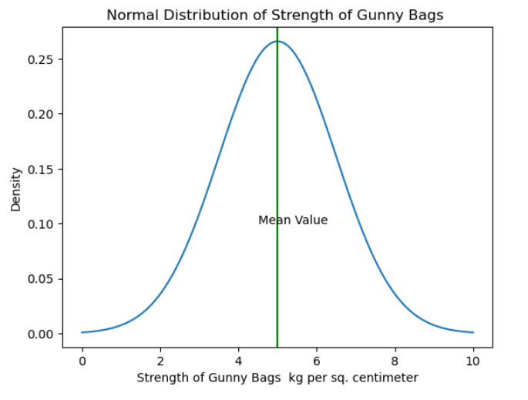

Figure : Normal Distribution of Strength of Gunny Bags

Given that breaking strength of gunny bags is normally distributed with a mean of 5 kg per sq. centimetre and a standard deviation of 1.5 kg per sq. centimetre. μ=5, σ =1.5

## 3.1 What proportion of the gunny bags have a breaking strength less than 3.17 kg per sq. cm?

Let P (X<3.17 ) is probability of gunny bags having a strength less than 3.17 kg per sq. .The

probability of breaking strength less than 3.17 kg per sq. cm is area as depicted in the shaded area. Using norm.cdf() we can find the area under the curve is equal to 0.11. So, probability of gunny bags having a strength less than 3.17 kg per sq. is 11%.

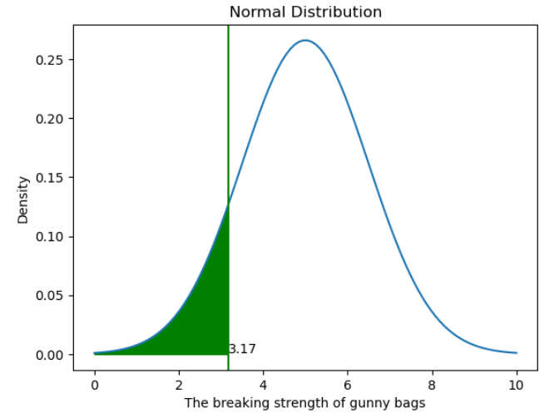

Figure : proportion of gunny bags having a strength less than 3.17 kg per sq.

## 3.2 What proportion of the gunny bags have a breaking strength at least 3.6 kg per sq. cm.?

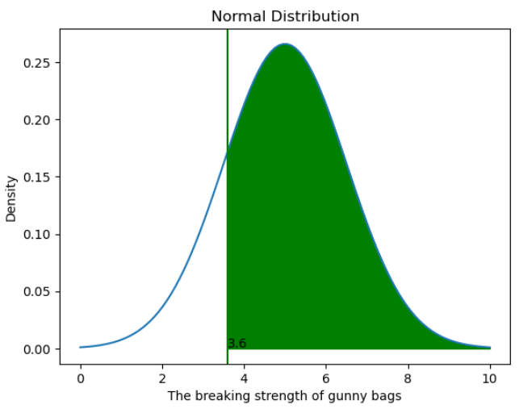

Figure proportion of gunny bags having a strength at least 3.6 kg per sq. cm

Let P(X>=3.6 ) is probability of gunny bags having a strength at least 3.6 kg per sq. cm.The

probability of breaking strength at least than 3.6 kg per sq. cm is area as depicted in the shaded area to the right of 3.6. Using norm.cdf() we can find the area under the curve is equal to 0.8247. So, probability of gunny bags having a strength at least 3.6 kg per sq. cm is 82.47%.

## 3.3 What proportion of the gunny bags have a breaking strength between 5 and 5.5 kg per sq. cm.?

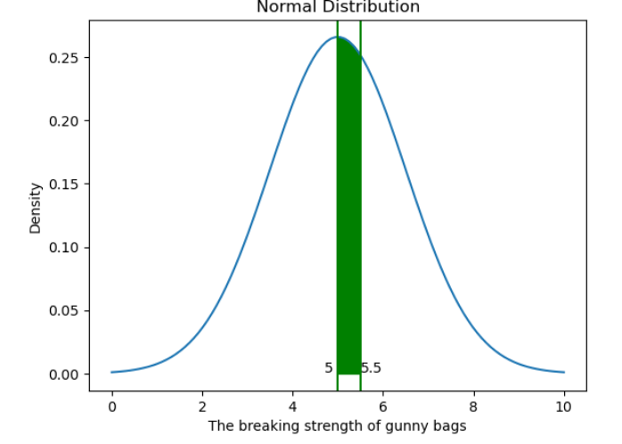

Figure : proportion of gunny bags having a breaking strength between 5 and 5.5 kg per sq. cm

Let P(5<X<5.5 ) is probability of gunny bags having a breaking strength between 5 and 5.5 kg per sq. cm.The probability of breaking strength between 5 and 5.5 kg per sq. cm is area as depicted in the shaded area between 5 and 5.5. We need to find area Using norm.cdf() we can find the area under the curve is equal to 0.13. The probability of breaking strength between 5 and 5.5 kg per sq. cm is 13%

## 3.4 What proportion of the gunny bags have a breaking strength NOT between 3 and 7.5 kg per sq. cm.?

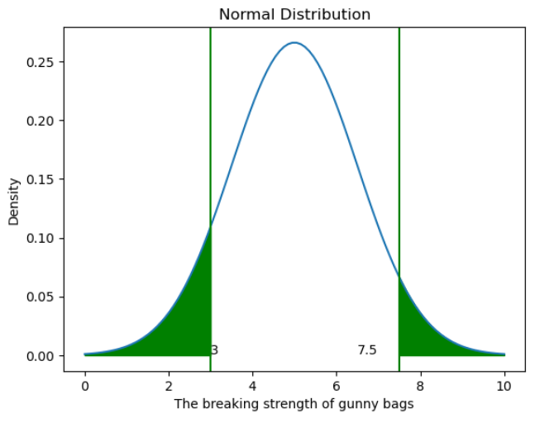

Figure : proportion of gunny bags not having a breaking strength between 3 and 7.5 kg per sq. cm

 Let P(X<3 and X>7.5 ) is probability of gunny bags having a breaking strength not between 3

and 7.5 kg per sq. cm.The probability of breaking strength not between 3 and 7.5 kg per sq. cm is area as depicted in the shaded area to the left of 3 and area to the right of 7.5. Using norm.cdf() we can find the area under the curve is equal to 0.139. So, the probability of gunny bags having a breaking strength not between 3 and 7.5 kg per sq. cm is 13.9%.

# Problem4

 Grades of the final examination in a training course are found to be normally distributed, with a mean of 77 and a standard deviation of 8.5. Based on the given information answer the questions below.

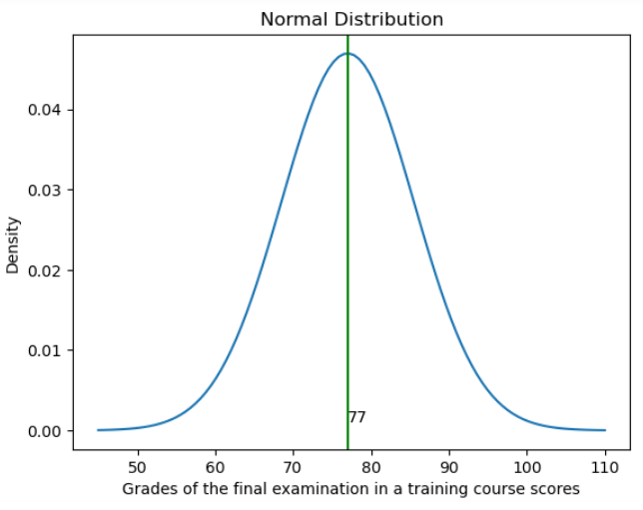

Figure Normal Distribution of grades of the final examination in a training course

Given that grades of the final examination in a training course are found to be normally distributed, with a mean of 77 and a standard deviation of 8.5. μ=77, σ =8.5

## 4.1 What is the probability that a randomly chosen student gets a grade below 85 on this exam?

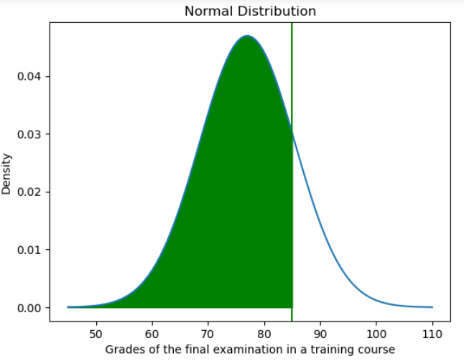

Figure : Density distribution of Scores with shaded area less than 85

**Ans:**Let P(X<85 ) be the probability of scoring less than 85 .The probability of scoring less than 85 is area as depicted in the shaded area to the left of 85. Using norm.cdf() we can find that the area under the curve is equal to 0.83 or **there is 83 % probability of scoring less than 85**

## 4.2 What is the probability that a randomly selected student score between 65 and 87?

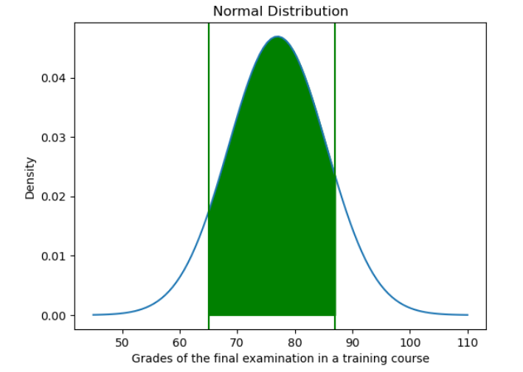

Figure : Density distribution of Scores with shaded area between 65 and 87

**Ans’**(87<X>65 ) is the green shaded area under the curve in probability distribution which is

0.8013

Let P(87<X>65 be the probability of scoring between 65 and 87 .The probability of scoring between 65 and 87 is area as depicted in the shaded area between 65 and 87. Using norm.cdf() we can find that the area under the curve is equal to 0.8013 or **there is 80.13 % probability of scoring between 65 and 87.**

## 4.3 What should be the passing cut-off so that 75% of the students clear the exam?

**Ans:**Give that Probability of 75% of students will pass the exam with a certain score, the score should be such that only 25% of students are below the score. Using percentage points function (ppf) we can find the score below which there 25% of students is 71.27.

**The passing cut off so that 75% of students clear the exam is 71.27**

## 

Figure :Passing Cut off to clear the exam

## Problem5

Zingaro stone printing is a company that specializes in printing images or patterns on polished or unpolished stones. However, for the optimum level of printing of the image the stone surface has to have a Brinell's hardness index of at least 150. Recently, Zingaro has received a batch of polished and unpolished stones from its clients. Use the data provided to answer the following (assuming a 5% significance level);

## 

**Ans:** Analyse the sample Data for Polished and Unpolished Stones from given dataset

Let’s load the Sample Data set for Polished and Unpolished Stones.

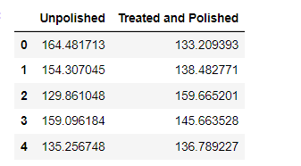

**Table 1: Displaying Top 5 records from the dataset**

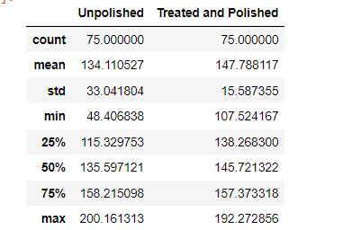

**Table 2 :Numerical summarization of the dataset**



**Table 3:Skewness of Variables**

The sample size of both polished and unpolished stones dataset is 75

Minimum Hardness for Unpolished stones is 48.4 whereas for Treated and Polished is 107.52

Mean Values of sample of Unpolished stones is 134.11 whereas for Treated and Polished is 147.78

Mean Values of sample of Unpolished stones is slightly less than Median indicating a left skewed distribution whereas mean values for Treated and Polished is more than the median indicating a right skew

The standard deviation of Unpolished stone is 33.04 whereas for Polished stones it is 15.59 indicating the values are more spread out in case of unpolished stones whereas values are closer to the mean in case of polished stones

There are outliers in both polished and Unpolished stones

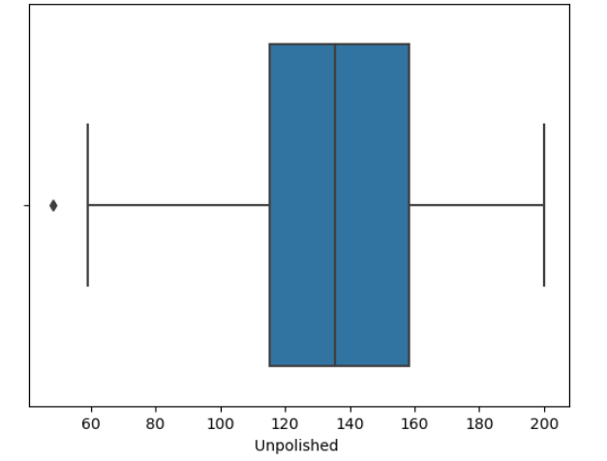 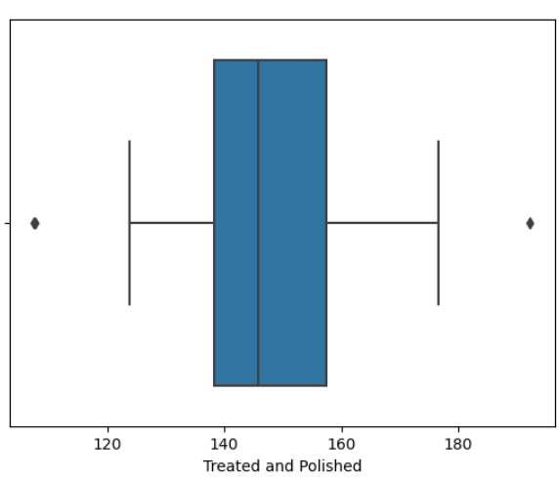

## 5.1 Earlier experience of Zingaro with this particular client is favourable as the stone surface was found to be of adequate hardness. However, Zingaro has reason to believe now that the unpolished stones may not be suitable for printing. Do you think Zingaro is justified in thinking so?

**Ans:** To test whether the unpolished stones are be suitable for printing or not, we use one Sample T-test on the sample data of Unpolished stones. We use one sample T test because population standard deviation is unknown and we have have a sample size of 75. One-sample t-test is a statistical hypothesis test that can be used to see if the mean of an unknown population differs from a given or known value

It is given that optimum level of printing of the image the stone surface has to have a Brinell's hardness index of at least 150, so let’s assume mean of the population is 150.We will use level of significance as 0.05

## Let's write the null and alternate hypotheses:

Null hypothesis 𝐻0 states that unpolished stones are suitable for printing and mean of stone hardness is more than or equal to 150

Alternative hypothesis 𝐻𝑎 states that unpolished stones are unsuitable for printing and mean of stone hardness is less than 150

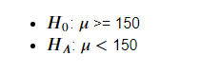

We assume that the samples are randomly selected, independent and come from a normally distributed population with unknown but equal variances.

Next step is to calculate the test statistic T.

A left-tailed test will be

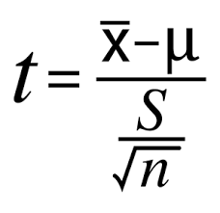

Equation 1: One sample T test

Where, is the sample mean, μ is the hypothesized population mean, S is the standard deviation of the sample and n is the number of observations in the sample.

=134.11, **=150, S=33.04,n=75**

Replacing the values in the formula the calculated T vales comes to -4.16.

Next, we will compare calculated T value with the critical T value to check if the calculated T value is less than more than critical value.

At a level of significance of 0.05 and degrees of freedom 74(n-1), the critical T-value for a left-tailed test comes out to be -1.66. Since the calculated T-value of -4.16 is much smaller than the critical value of -1.66, the calculated T value lies in the rejection region .Hence the null hypothesis can be rejected. Thus, there is a statistically significant difference between sample mean and the population mean.

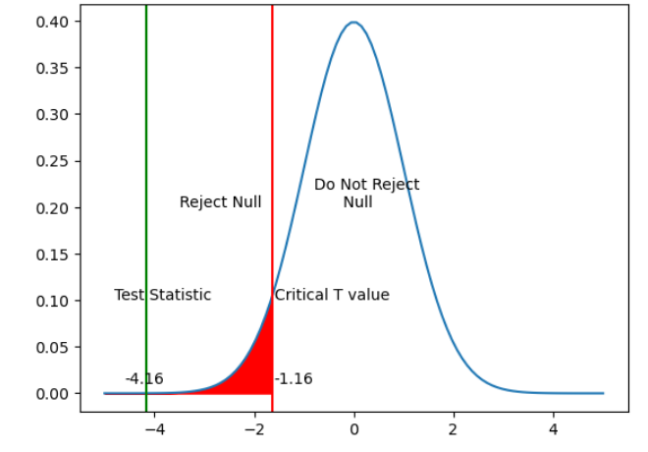

Figure :Plotting of calculated T value

Another way to test is to calculate the p-value for getting the T-statistics of -4.16. For a T-statistics of -4.16, the p-value came out to be 0. 0000417. This means that there is a probability of only 0.0000417 to get this kind of sample given the null hypothesis holds good. As this value is less than 0.05, one can reject the null hypothesis given the evidence of current sample.

With this we conclude that Zingaro was right in saying that unpolished stones are unsuitable for printing

## 5.2 Is the mean hardness of the polished and unpolished stones the same?

**Ans:** To test whether the mean hardness of the polished and unpolished stones the same, we use two Sample independent T-test on Unpolished and Polished stone samples. Independent sample t-test is used to find out if the differences between two groups is actually significant or just a random occurrence. We can use this when:

* the population mean or standard deviation is unknown.
* the two samples are independent.

We will use level of significance as 0.05

## Let's write the null and alternate hypotheses:

Null hypothesis states that the null hypothesis states that the mean hardness of polished and unpolished stones are the same

Alternative hypothesis states that the mean hardness of polished and unpolished stones is the different

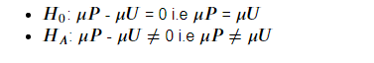

The formula for the two-sample t test when variances of groups are different is shown below.

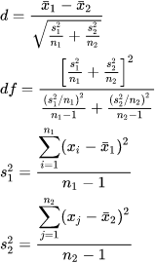

Equation 2: 2 sample Independent T test

In this formula, d is the test statistic, x1 and x2 are the means of the two groups being compared,   and  are variances of the two groups, and n1 and n2 are the number of observations in each of the groups, df is the degrees of freedom

The numerator of the test statistic is the difference between the averages of the two groups. The denominator is an estimate of the overall standard error of the difference between means. It is based on the separate standard error for each group.

Using the above formula and substituting the values, the calculated T- value comes to -3.2422.

At a level of significance of 0.05 and degrees of freedom 105.382, the critical T-value for a two-tailed test comes out to be -1.982. Since it’s a two tailed test , critical T- value on other side will be 1.982

Since the calculated T-value of -3.242 is much smaller than the critical value of -1.982, the null

hypothesis can be rejected.

Thus, there is a statistically significant difference between sample means of Polished and

Unpolished stones

Another way to test is to calculate the p-value for getting the T-statistics of - 3.24 or 3.24 since it’s a two tailed test . For a T-statistics of -3.24 or 3.24, the p-value came out to be 0.0014. This means that there is a probability of only 0.0014 to get these kinds of samples with equal means

given the null hypothesis holds good. As this value is less than 0.05, one can reject the null hypothesis given the evidence of current samples.

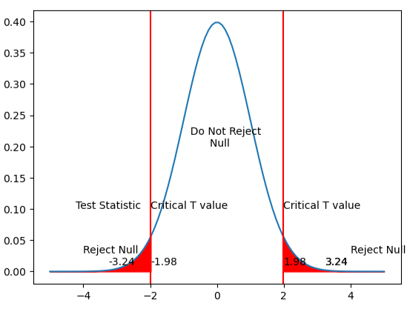

Figure : Plotting of calculated T value of samples of polished and unpolished means

**With this we conclude that means of polished and unpolished stones are different**.

# Problem6

Aquarius health club, one of the largest and most popular cross-fit gyms in the country has been advertising a rigorous program for body conditioning. The program is considered successful if the candidate is able to do more than 5 push-ups, as compared to when he/she enrolled in the program. Using the sample data provided can you conclude whether the program is successful? (Consider the level of Significance as 5%)

Note that this is a problem of the paired-t-test. Since the claim is that the training will make a difference of more than 5, the null and alternative hypotheses must be formed accordingly.

**Ans:** Let’s analyse the dataset provided

Analyse the sample Data for number of push-ups the candidate is able to do before and after the program for body conditioning

Let’s load the Sample Data set for before and after results

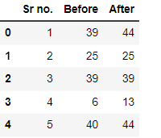

**Table 4: Displaying top 5 records of the dataset of Aquarius health club before and after program**

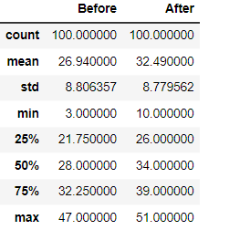

**Table 5: Numerical summarization of the dataset before and after the program**

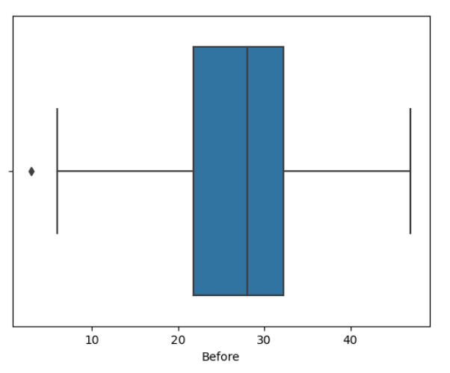

Figure : Boxplot of No of Push-ups Before Program

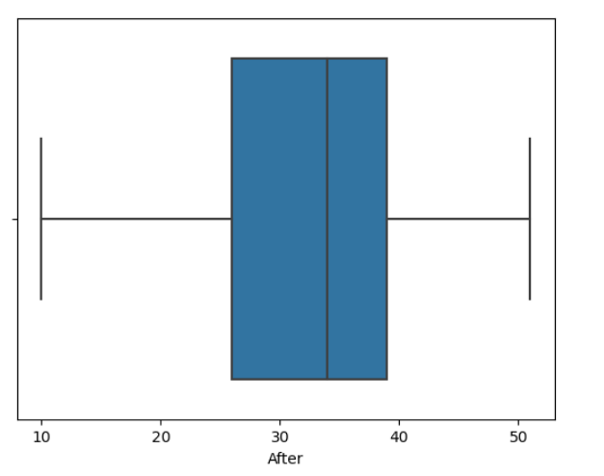

Figure : Boxplot of No of Push-ups After Program

The sample size of both polished and unpolished stones dataset is 100

Minimum Push ups before the program is 3 and after the program is 10

Mean Values of push-ups before program is 27 whereas Mean Values of push-ups after program is 32

Mean Values of push-ups before program is greater than median value indicating a right skew

Mean Values of push-ups after program is less than median value indicating a left skew

The standard deviation of before program push-ups is 8.8 and after push-sups is 8.77 indicating similar spread of values

To test the hypothesis, we start by calculating the difference between the before and after program for each observation , we create a new column calculating difference between the before and after values

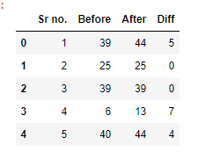

Figure : New column calculating the difference between number of push-ups before and after

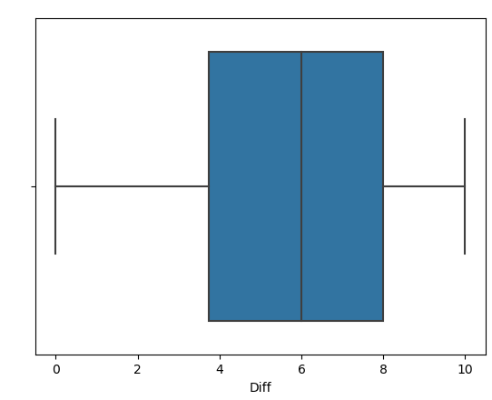

Figure : Plotting the difference of means

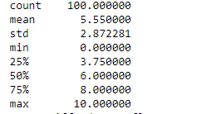

**Table 6: describing the sample difference**

There are no outliers in the difference of samples, sample mean value of the difference is 5.55

sample standard deviation of the differences is 2.87

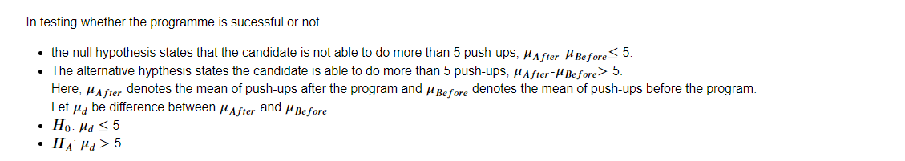

We will be using a paired T test to test the hypothesis

We use the following formula to calculate the test statistic t:

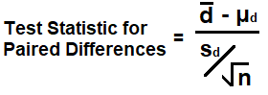

Equation 3: Paired T test

where:

* **:**sample mean of the differences which is 5.5
* **:**population mean differences which is assumed to be equal to 5
* **:**sample standard deviation of the differences which is 2.87
* sample size (i.e., number of pairs) which is 100

The assumptions before the test are

* The participants are selected randomly from the population.
* The differences between the pairs are approximately normally distributed.
* There are no extreme outliers in the differences.

The hypothesis test is one-tailed because in alternative hypothesis we are checking if candidate is able to do more than 5 push-ups

Replacing values in the above formula we get calculated t value as 1.91485

At a level of significance of 0.05 and degrees of freedom as 99(n-1), the T-value for a one-tailed test comes out to be 1.6603. Since the calculated T-value of 1.91485 is much greater than the critical value of 1.6603, the null hypothesis can be rejected. We can see from the fig below that the test statistic lies in the rejection region

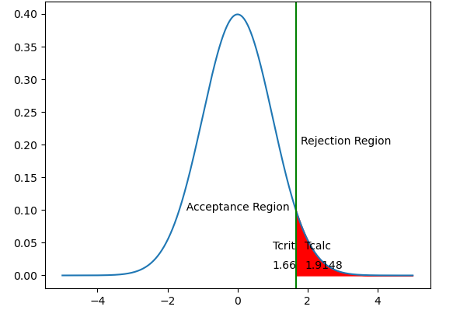

Figure : Plotting of calculated T value of difference of samples of before and after the program

Another way to test is to calculate the p-value for getting the T-statistics of 1.91485

For a T-statistics of 1.91485 the p-value came out to be 0.0291. This means that there is a probability of only 0.0291 to get these kinds of samples with equal means given the null hypothesis holds good. As this value is less than 0.05, one can reject the null hypothesis given the evidence of current samples.

**With this we can conclude that candidate is able to more than 5 push-ups after the new program.**

# Problem7

Dental implant data: The hardness of metal implant in dental cavities depends on multiple factors, such as the method of implant, the temperature at which the metal is treated, the alloy used as well as on the dentists who may favour one method above another and may work better in his/her favourite method. The response is the variable of interest.

**Ans:** Loading the dataset

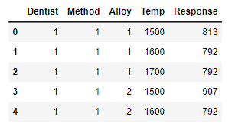

Figure :Top 5 records of Dental Implant Hardness Data

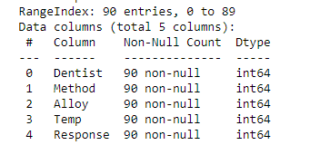

Figure : Columns of the Dataset

There are 90 records in this data set

Dentist, Method, Alloy and Temp are categorical values and Response is a continuous numerical variable.

There are 5 dentists {1,2 3,4 5}, 2 types of Methods {1,2,3}, 2 types of Alloys {1,2},3 Types of Temp values {1500,1600,1700}.

Let’s plot the Response Variable.

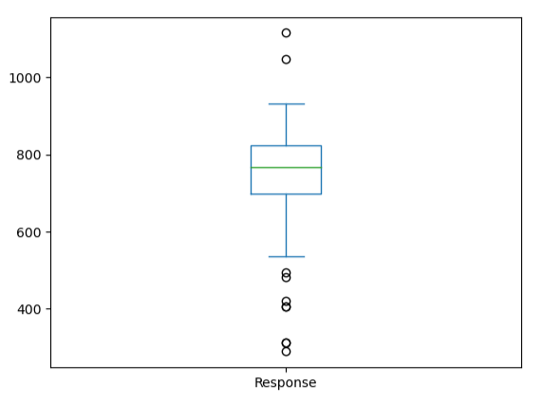

Figure : Plotting of Response Variable

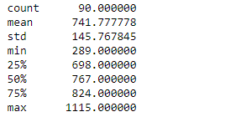

**Table 7: Describing Response Variable**

The response variable has a mean of 741.77 with a standard deviation of 145.76. There are some outliers as seen in the boxplot below.

Since Dentist, Method, Alloy and Temp are categorical variables we can change the data type in the dataset

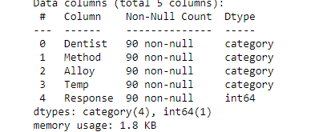

**Table 8: Data set description after changing datatypes.**

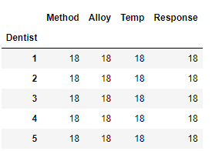

**Table 9: Crosstab of Dentist vs other variables**

From the above table we can see that there are equal number of records across all dentists.

From the above dataset we see that there is one dependent variable Response which is the Implant hardness. There are 4 independent variables Dentist, Method, Alloy and Temp.

We will be using ANOVA test t**o** compare the means among three or more groups**.** The goal of the ANOVA test is to check for variability within the groups as well as the variability among the groups within a sample considering independent variable also called factors . A one-way ANOVA is a type of statistical test that compares the variance in the group means within a sample considering one independent variable whereas two-way ANOVA determines the effect of two factors or independent variables on a dependent variable .The ANOVA test statistic is determined by the f test.

Before proceeding with the hypothesis test, we will make a subset of the dataset to state null and alternative hypothesis separately for two types of alloys.

dentist_df_Alloy1 subset will have records of Alloy 1

dentist_df_Alloy2 subset will have records of Alloy 2

## 7.1 Test whether there is any difference among the dentists on the implant hardness. State the null alternative hypotheses. Note that both types of alloys cannot be considered together. You must state the null and alternative hypotheses separately for the two types of alloys.?

**Ans:** To test the Implant Hardness across dentists, lets plot the response variable for all dentists for both alloys. Crosstab of Dentists Vs Mean Hardness for both alloys are as follows

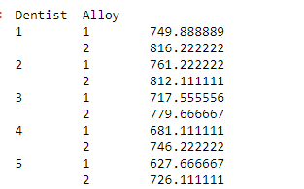

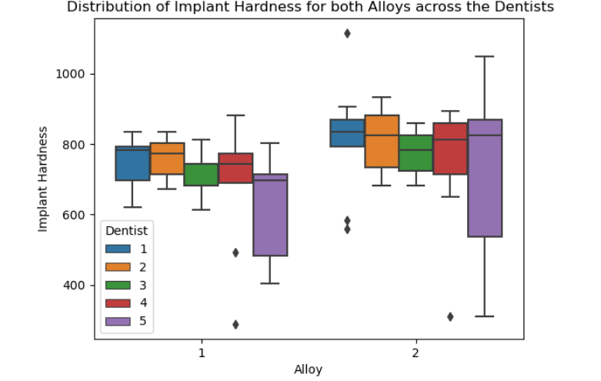

Figure : Plotting the Implant Hardness among the dentists for both Alloys

There is no significant different among the dentists in implant hardness using a particular alloy in the give n samples. However, we can see that mean hardness of Alloy 2 is greater than that of Alloy 1 across all dentists.

To conclude that there is a difference or not among dentists for a population, we need to do ANOVA test. But before that lets state Null and Alternate Hypothesis

Null and Alternate Hypothesis:

* The Null Hypothesis states that there is no difference among the dentists on the mean Implant hardness for Alloy1. H0: μ1 = μ2 = μ3= μ4= μ5
* The Null Hypothesis states that there is no difference among the dentists on the mean Implant hardness for Alloy2. H0: μ1 = μ2 = μ3= μ4= μ5
* The Alternate Hypothesis states that there is a difference among dentists on the mean Implant hardness for Alloy1.: μ1 ≠ μ2 ≠ μ3≠ μ4 μ5
* The Alternate Hypothesis states. that there is a difference among dentists on the mean Implant hardness for Alloy2 : μ1 ≠ μ2 ≠ μ3≠ μ4 μ5

## 7.2 Before the hypotheses may be tested, state the required assumptions. Are the assumptions fulfilled? Comment separately on both alloy types.?

**Ans:** Before testing the Hypothesis, we assume the following:

**Randomness and Independence**-Random samples of Hardness of Implants form the category groups and the hardness measurements of the implants are independent of each other for Alloy 1

**Normality**- The hardness measurements follow a normal distribution for Alloy 1

**Homogeneity of Variance**- The variances of the hardness measurements are equal for all dentists using Alloy 1.

**Randomness and Independence**-Random samples of Hardness of Implants form the category groups and the hardness measurements of the implants are independent of each other for Alloy 2

**Normality**- The hardness measurements follow a normal distribution for Alloy 2

**Homogeneity of Variance**- The variances of the hardness measurements are equal for all dentists using Alloy 2.

## 7.3Irrespective of your conclusion in 2, we will continue with the testing procedure. What do you conclude regarding whether implant hardness depends on dentists? Clearly state your conclusion. If the null hypothesis is rejected, is it possible to identify which pairs of dentists differ?

**Ans:** Lets plot the Implant Hardness among the Dentists for both Alloys



In testing whether there is any difference among dentists on implant hardness

* The Null Hypothesis states that there is no difference among the dentists on the mean Implant hardness for Alloy1. H0: μ1 = μ2 = μ3= μ4= μ5
* The Null Hypothesis states that there is no difference among the dentists on the mean Implant hardness for Alloy2. H0: μ1 = μ2 = μ3= μ4= μ5
* The Alternate Hypothesis states that there is a difference among dentists on the mean Implant hardness for Alloy1.: μ1 ≠ μ2 ≠ μ3≠ μ4 μ5
* The Alternate Hypothesis states. that there is a difference among dentists on the mean Implant hardness for Alloy2 : μ1 ≠ μ2 ≠ μ3≠ μ4 μ5

Here, μ1 denotes the mean of dental hardness among patients of Dentist1, μ2 denotes the mean of dental hardness among patients of Dentist2, μ3 denotes the mean of dental hardness among patients of Dentist3 μ4denotes the mean of dental hardness among patients of Dentist4, μ5 denotes the mean of dental hardness among patients of Dentist5

Significance level is assumed to 0.05

The ANOVA technique applies when there are two or more than two independent groups in this case there are 5 dentists’ groups. The independent variable here is the dentists and the dependent variable is the Implant hardness called Reponses Variable in the dataset. Since we are checking only 1 independent variable, we can do a one-way ANOVA test. We will compute the F statistic separately for both Alloys

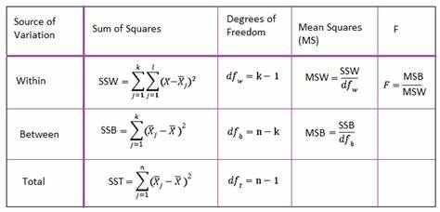

Equation 4: ANOVA one way test

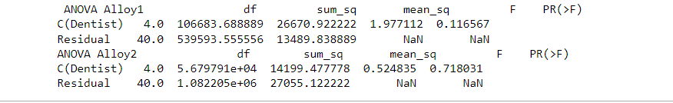

Figure : One -way ANOVA test for Dentists for both Alloys

Using ANOVA test we can find F value for Alloy 1 is 1.97712, meaning Variance between the groups is not very high as compared to variance within the group

Using ANOVA test we can find F value for Alloy 2 is 0.5248, meaning Variance between the groups is not very high as compared to variance within the group

With ANOVA one way p-value as 0.11656 for Alloy 1 which is more than the value of significance 0.05, therefore we do not have enough evidence to reject the null hypothesis in favour of alternative hypothesis.

With ANOVA one way p-value as 0.7180 for Alloy 2 which is more than the value of significance 0.05,

therefore, we do not have enough evidence to reject the null hypothesis in favour of alternative hypothesis.

We conclude with a confidence level of 95% that Means of Implant Hardness is same across all dentists

for both Alloys.

Equality of means hypothesis is not rejected, we need not find out which group means are

different from the rest. Tukey-test for multiple comparisons can be applied to check which mean groups are different in case null hypothesis is rejected

## 7.4Now test whether there is any difference among the methods on the hardness of dental implant, separately for the two types of alloys. What are your conclusions? If the null hypothesis is rejected, is it possible to identify which pairs of methods differ?

**Ans:** Lets plot the Implant Hardness among the Methods for both Alloys

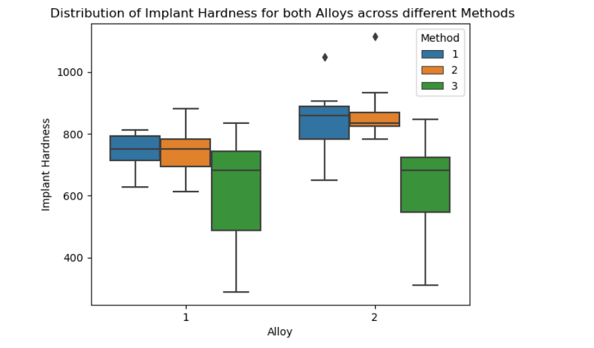

Figure : Plotting the Implant Hardness among the Methods for both Alloys

To conclude that there is a difference or not among Methods for a population, we need to do ANOVA test. But before that lets state Null and Alternate Hypothesis for both Alloys

Null and Alternate Hypothesis:

* The Null Hypothesis states that there is no difference among the methods on the mean Implant hardness for Alloy1. H0: μ1 = μ2 = μ3
* The Null Hypothesis states that there is no difference among the methods on the mean Implant hardness for Alloy2. H0: μ1 = μ2 = μ3
* The Alternate Hypothesis states that there is a difference among at least one pair of methods on the mean Implant hardness for Alloy1.: μ1 ≠ μ2 ≠ μ3
* The Alternate Hypothesis states. that there is a difference among at least one pair of methods on the mean Implant hardness for Alloy2 : μ1 ≠ μ2 ≠ μ3

Here, μ1 denotes the mean of dental hardness using method1, μ2 denotes the mean of dental hardness using method2, μ3 denotes the mean of dental hardness using method3

Significance level is assumed to 0.05

The ANOVA technique applied when there are two or more than two independent groups in this case there are 3 method groups. The independent variable here is the method and the dependent variable is the Implant hardness. Sine we are checking only 1 independent variable we can do a one-way ANOVA test. We will compute the F statistic separately for both Alloys

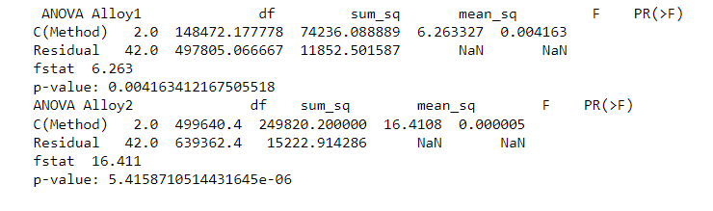

Figure : One -way ANOVA test for Methods for both Alloys

Using ANOVA test we can find F value for Alloy 1 is 6.2633, meaning Variance between the groups is high as compared to variance within the group

Using ANOVA test we can find F value for Alloy 2 is 16.4108, meaning Variance between the groups is very high as compared to variance within the group

With ANOVA one way p-value as 0.004163 for Alloy 1 which is less than the value of significance 0.05,

therefore, we have enough evidence to reject the null hypothesis in favour of alternative hypothesis.

With ANOVA one way p-value as 0.000005 for Alloy 2 which is less than the value of significance 0.05, therefore we have enough evidence to reject the null hypothesis in favour of alternative hypothesis.

We conclude with a confidence level of 95% that Means of Implant Hardness is not same across all methods for both Alloys. There is a difference in at least one pair. To find which pair is

different we can use Tukey test

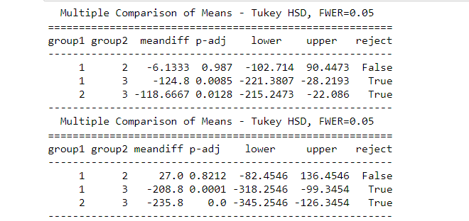

Figure : Tukey test for Methods for both Alloys

Using the Tukey test we can find out means of Implant Hardness is different for Method pair 1 & 3 and 2 & 3. As we can also see from the boxplot above Method 3 has mean much lower than Method 1 and 2

## 7.5Now test whether there is any difference among the temperature levels on the hardness of dental implant, separately for the two types of alloys. What are your conclusions? If the null hypothesis is rejected, is it possible to identify which levels of temperatures differ?

**Ans:** Lets plot the Implant Hardness among the Temperature for both Alloys

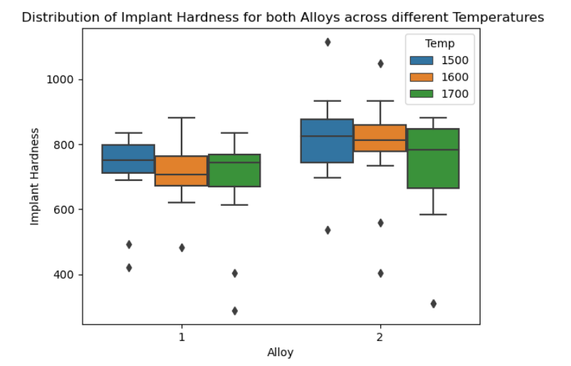

Figure : Plotting the Implant Hardness among the Temperature for both Alloys

To conclude that there is a difference or not among Temperatures on the mean Implant hardness for a population, we need to do ANOVA test. But before that lets state Null and Alternate Hypothesis for both Alloys

Null and Alternate Hypothesis:

* The Null Hypothesis states that there is no difference among the temperatures on the mean Implant hardness for Alloy1. H0: μ1 = μ2 = μ3= μ4= μ5
* The Null Hypothesis states that there is no difference among the temperatures on the mean Implant hardness for Alloy2. H0: μ1 = μ2 = μ3= μ4= μ5
* The Alternate Hypothesis states that there is a difference among temperatures on the mean Implant hardness for Alloy1.: μ1 ≠ μ2 ≠ μ3≠ μ4 μ5
* The Alternate Hypothesis states. that there is a difference among temperatures on the mean Implant hardness for Alloy2 : μ1 ≠ μ2 ≠ μ3≠ μ4 μ5

Here, μ1 denotes the mean of dental hardness of temperature1, μ2 denotes the mean of dental hardness of temperature2, μ3 denotes the mean of dental hardness of temperature3

Significance level is assumed to 0.05

The ANOVA technique applies when there are two or more than two independent groups in this case there are 3 temperature groups. The independent variable here is the temperature and the dependent variable is the Implant hardness. Sine we are checking only 1 independent variable we can do a one-way ANOVA test. We will compute the F statistic separately for both Alloys

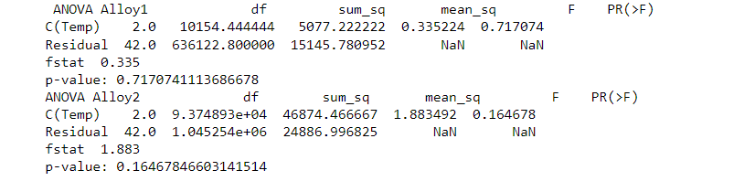

Figure : One -way ANOVA test for Temperature for both Alloys

Using ANOVA test we can find F value for Alloy 1 is 0.33522, meaning Variance between the groups is not very high as compared to variance within the group

Using ANOVA test we can find F value for Alloy 2 is 1.88349, meaning Variance between the groups is not very high as compared to variance within the group

With ANOVA one way p-value as 0.71707 for Alloy 1 which is more than the value of significance 0.05, therefore we do not have enough evidence to reject the null hypothesis in favour of alternative hypothesis.

With ANOVA one way p-value as 0.16467 for Alloy 2 which is more than the value of significance 0.05, therefore we do not have enough evidence to reject the null hypothesis in favour of alternative hypothesis.

We conclude with a confidence level of 95% that Means of Implant Hardness is same across all

temperatures for both Alloys

Equality of means hypothesis is not rejected, we need not find out which group means are

different from the rest. Tukey-test for multiple comparisons can be applied to check which mean groups are different in case null hypothesis is rejected

## 7.6Consider the interaction effect of dentist and method and comment on the interaction plot, separately for the two types of alloys?

**Ans:** Let’s plot the Interaction effect of dentist and Method. We will visualize the interaction between categorical factors Methods and Dentists using interaction plot method.

Dentist is plotted in X-axis and response variable (mean Implant Hardness) will be plotted on Y-axis and the Methods will be used a hue to differentiate the different methods

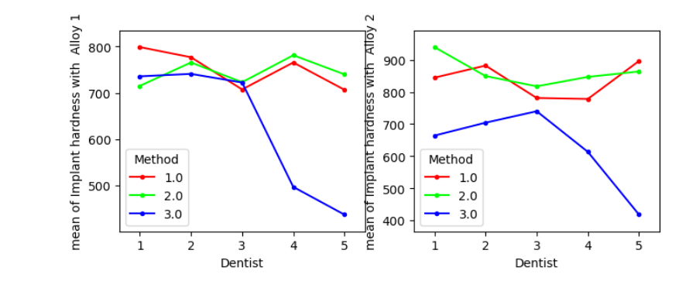

Figure : Plotting the Interaction effect of dentist and method

 Interaction Plot shows how the relationship between Dentists and a continuous response variable depends on the type of the Method. This plot displays means for the levels of Dentist on the x-axis and a separate line for each level of Method.

To understand how the interactions affect the relationship between the factors and the response we evaluate the lines Parallel lines indicate No interaction occurs. Nonparallel lines indicate an interaction occurs. The more nonparallel the lines are, the greater the strength of the interaction.

From the above figure we see that there is significant Interaction between Dentist and Methods

## 7.7Now consider the effect of both factors, dentist, and method, separately on each alloy. What do you conclude? Is it possible to identify which dentists are different, which methods are different, and which interaction levels are different?

**Ans:** Plotting the mean Implant Hardness among the Dentists with different Methods for both Alloy1 and Alloy2

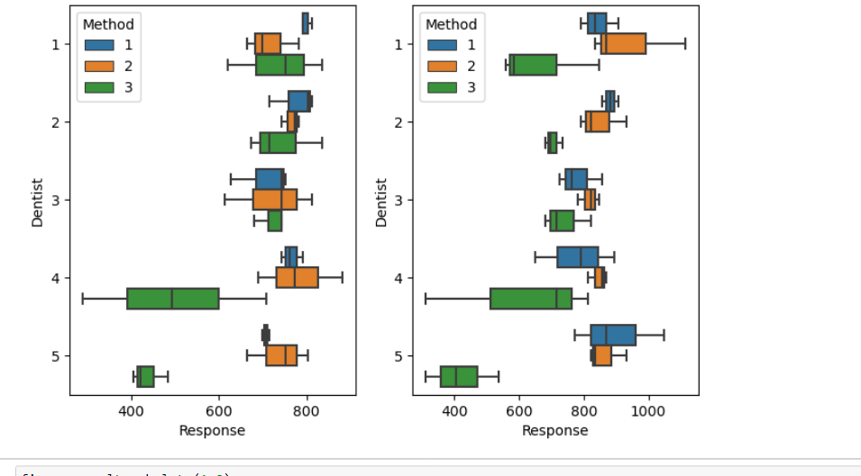

Figure Plotting the mean Implant Hardness among the Dentists with different Methods for Alloy1



Figure : Plotting the mean Implant Hardness among the Dentists with different Methods for Alloy2

We can check the interaction of two independent variables Method and Dentists and one dependent variable Implant Hardness using two-way ANOVA

A two-way ANOVA with interaction tests three null hypotheses at the same time:

**Null Hypothesis and Alternate Hypothesis for Alloy 1**

Null Hypothesis states that there is no difference in group means at any level of the independent variable Dentist for Alloy1.

Null Hypothesis states that there is no difference in group means at any level of the independent variable Method Alloy1

Null Hypothesis states that the effect of one independent variable does not depend on the effect of the other independent variable (a.k.a. no interaction effect) for Alloy1

Alternate Hypothesis states that there is a difference in group means at any level of the independent variable Dentist for Alloy1

Alternate Hypothesis states that there is a difference in group means at any level of the independent variable Method for Alloy1

Alternate Hypothesis states that the effect of one independent variable depends on the effect of the other independent variable for Alloy1

**Null Hypothesis and Alternate Hypothesis for Alloy 2**

Null Hypothesis states that there is no difference in group means at any level of the independent variable Dentist for Alloy2

Null Hypothesis states that there is no difference in group means at any level of the independent variable Method Alloy2

Null Hypothesis states that the effect of one independent variable does not depend on the effect of the other independent variable (a.k.a. no interaction effect) for Alloy2

Alternate Hypothesis states that there is a difference in group means at any level of the independent variable Dentist for Alloy2

Alternate Hypothesis states that there is a difference in group means at any level of the independent variable Method for Alloy2

Alternate Hypothesis states that the effect of one independent variable depends on the effect of the other independent variable for Alloy2

The ANOVA technique applies when there are two or more than two independent groups.

In this case there are 5 dentists and 3 methods groups. The independent variables here are the dentists and methods and the dependent variable is the Implant hardness. Sine we are checking 2 independent variable we can do a two-way ANOVA test. We will also be checking interaction between the independent variables on the Implant hardness We will compute the F statistic separately for both Alloys

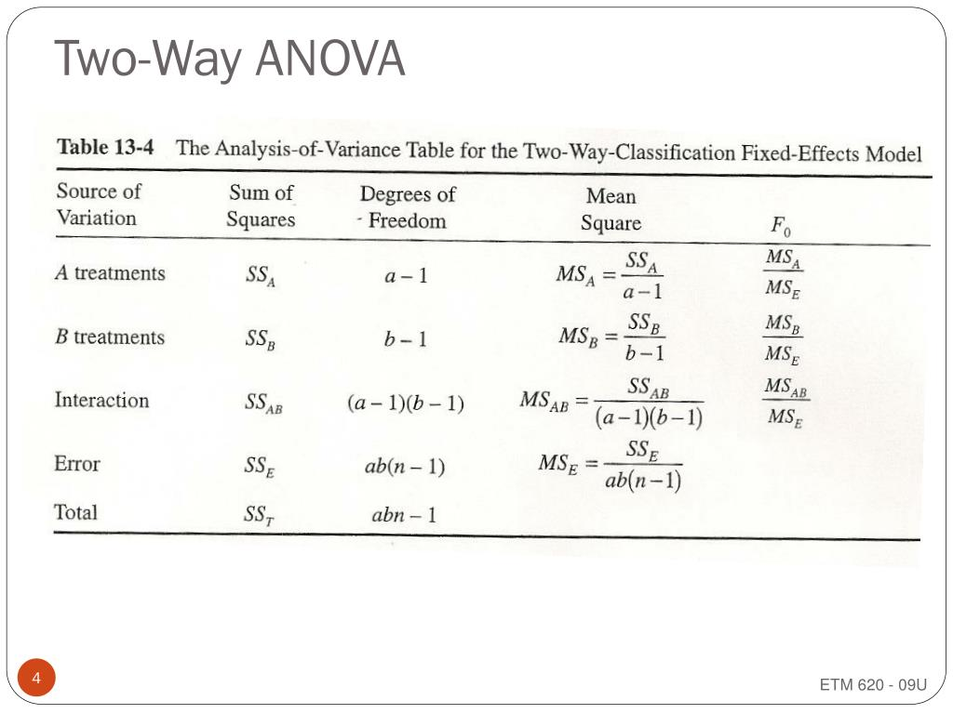

Equation 5: Two ANOVA with Interaction

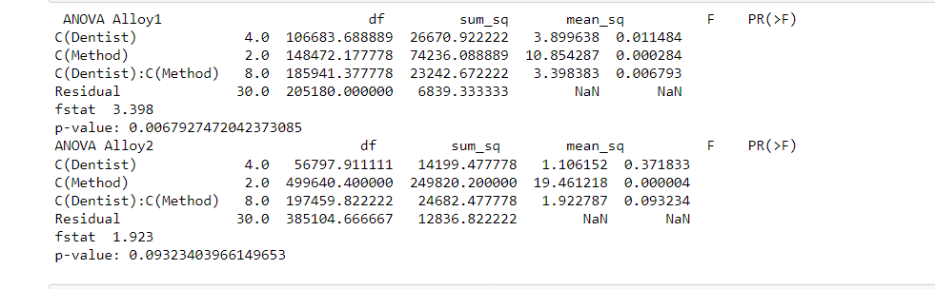

Figure : Two-way ANOVA testing Dentist and Methods and Interaction of Both the independent variables

Using ANOVA test we can find F value of Dentists for Alloy 1 is 3.899, meaning Variance between the groups is slightly high as compared to variance within the group

Using ANOVA test we can find F value of Dentists for Alloy 2 is 1.106, meaning Variance between the groups is not very high as compared to variance within the group

Using ANOVA test we can find F value of Methods for Alloy 1 is 10.85, meaning Variance between the groups is very high as compared to variance within the group

Using ANOVA test we can find F value of Methods for Alloy 2 is 19.46, meaning Variance between the groups is very high as compared to variance within the group

Using ANOVA test we can find F value of interaction between Dentists and Method for Alloy 1 is 3.398383, meaning Variance between the groups is slightly high as compared to variance within the group

Using ANOVA test we can find F value of interaction between Dentists and Method for Alloy 2 is 1.922787, meaning Variance between the groups is not very high as compared to variance within the group

With ANOVA two-way p-value for dentists as 0.011 for Alloy1 which is less than the value of

significance of 0.05, therefore we have enough evidence to reject the null hypothesis in favour of alternative hypothesis.We conclude that there is difference among Dentists for Alloy1

With ANOVA two-way p-value for dentists as 0.37 for Alloy 2 which is more than the value of significance of 0.05, therefore we do not have enough evidence to reject the null hypothesis in

favour of alternative hypothesis. We conclude that there is no difference among Dentists for Alloy2

With ANOVA two-way p-value for methods as 0.0002 for Alloy1 which is less than the value of significance of 0.05, therefore we have enough evidence to reject the null hypothesis in favour of alternative hypothesis.

We conclude that there is difference among methods for Alloy1

With ANOVA two-way p-value for methods as 0.000004 for Alloy 2 which is less than the value of significance of 0.05, therefore we have enough evidence to reject the null hypothesis in favour of alternative hypothesis.

We conclude that there is difference among methods for Alloy2

With ANOVA two-way p-value for interaction among dentists and methods is 0.006793 for

Alloy1 which is less than the value of significance of 0.05, therefore we have enough evidence to reject the null hypothesis in favour of alternative hypothesis.

We conclude that there is interaction among methods and Dentists for Alloy1

With ANOVA two-way p-value for interaction among dentists and methods is 0.093 for Alloy 2 which is more than the value of significance of 0.05, therefore we do not have enough evidence

to reject the null hypothesis in favour of alternative hypothesis.

We conclude that there is no interaction among methods and Dentists for Alloy2

Using Tukey test it is possible to identify which dentists are different, which methods are

different, and which interaction levels are different.

To check interaction using Tukey test we create a new column Dentist Method to form group

based on combination of Dentist and Method. So, for each pair of Dentist and Method

combination is checked against another pair of dentist and Method. The figures 32 below show the combinations which are most interaction for Alloy 1 and the figures 33 below show the combinations which are most interaction for Alloy 2

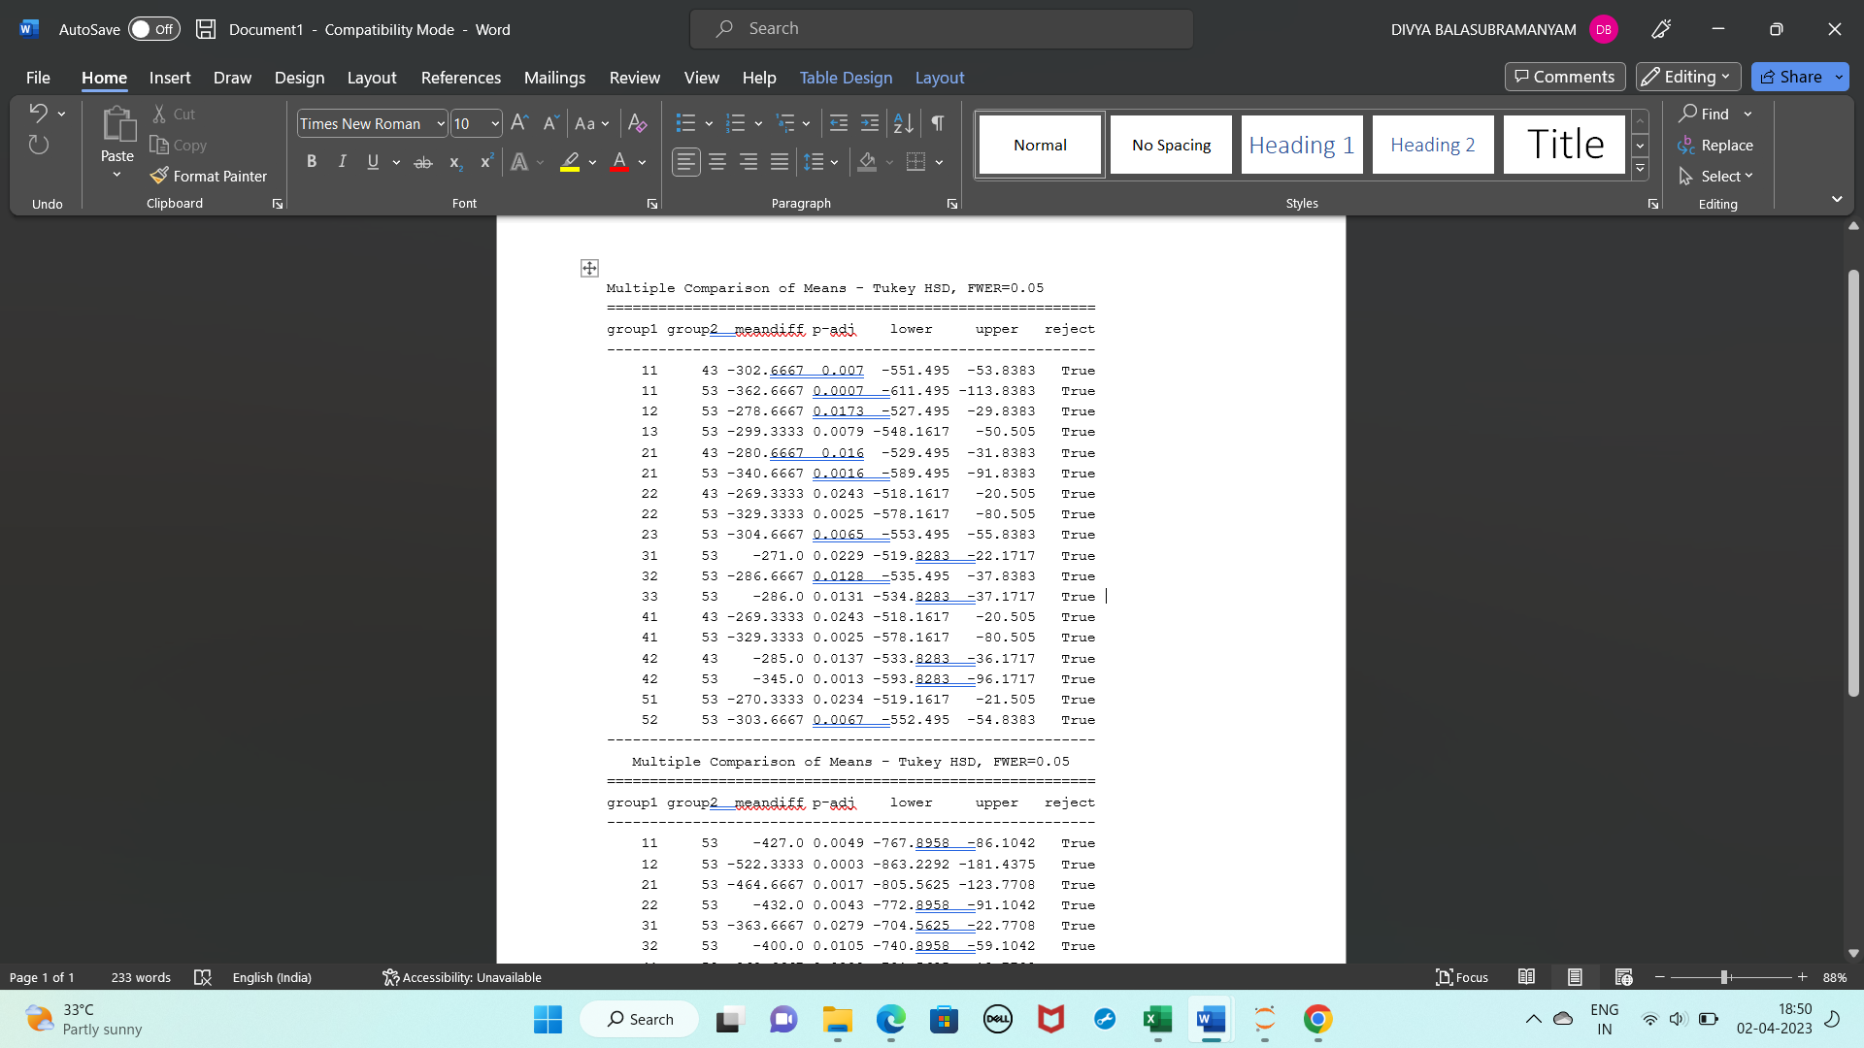

Figure :Tukey Test for interaction for Alloy 1

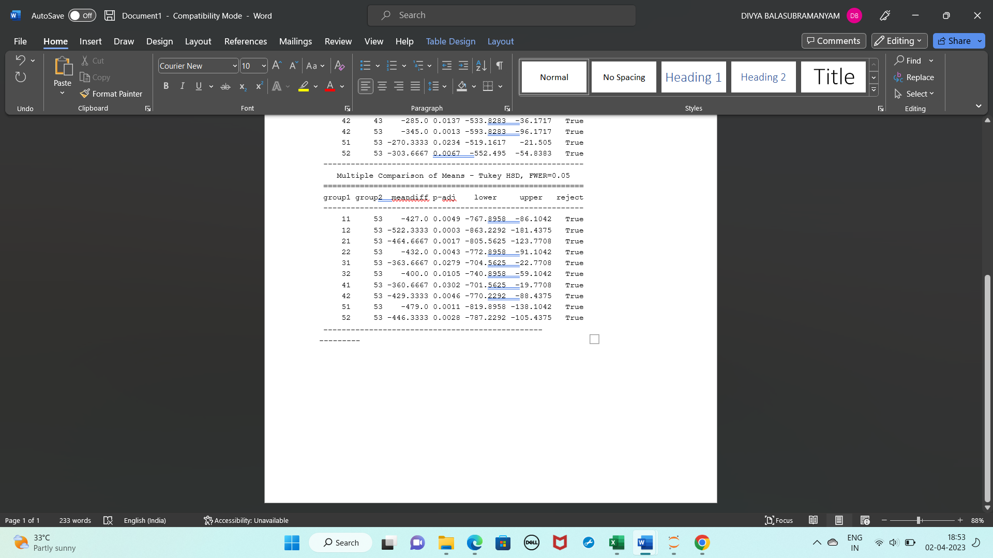

Figure : Tukey Test for interaction for Alloy 2

From the Tukey test we can see dentist and method combination 43 and 53 seem to be most different pair from the rest of the pairs as can also be observed from box plot fig 29 and fig 30